Amarathn
Var Fireworks (Globe)
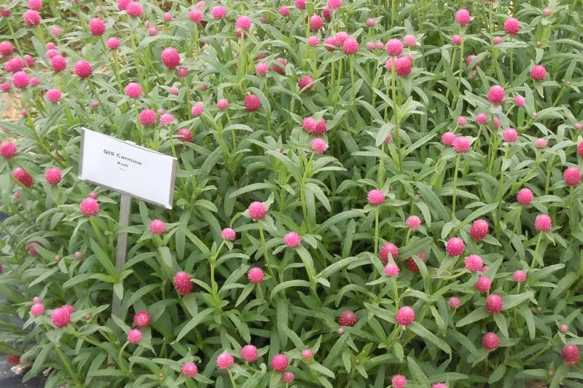
Var Caudatus Love Lies Bleeding
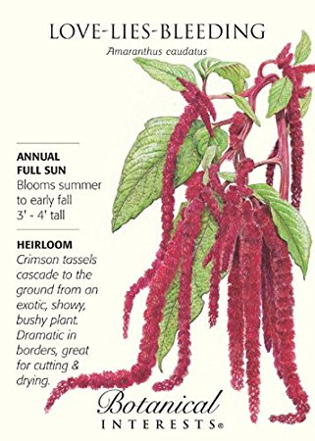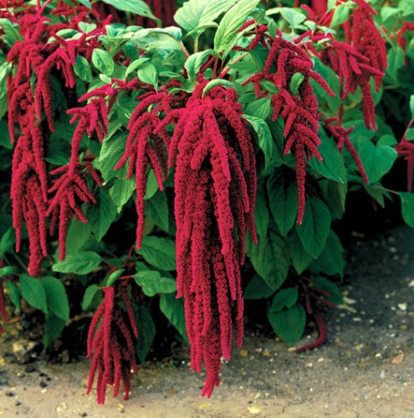
Cosmos
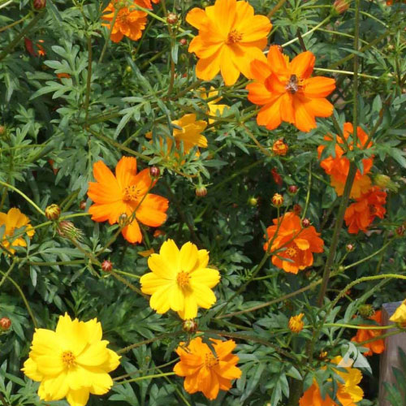
Dusty Miller
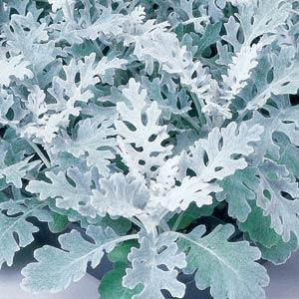
Echinacea-
Purple 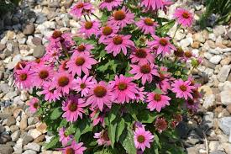
Marigolds var Alaskan
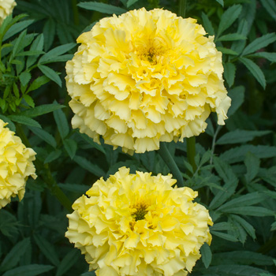
Rose Mallow
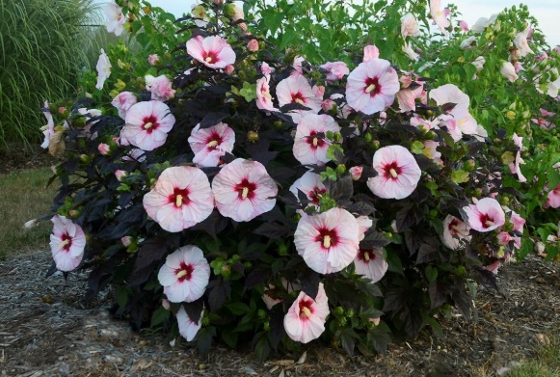
Perennial: sun to part shade, grows -5 ft tall, flowers are 8 inch, original plant from White Flower Farm, Stellar donator: Nolini

Sunflowers Non Specific
Multibloomer
And
Large 10-12 inch bloom

